Q1.Suppose you have a list of numbers. Using a lambda function, increase each number by 5%?.

Soln.

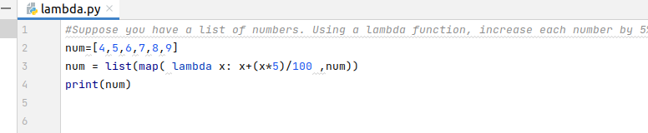

Output:

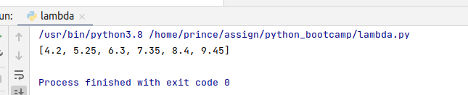

Q2.create a filter which filters out all the prime numbers from a given list of integers.

Soln.

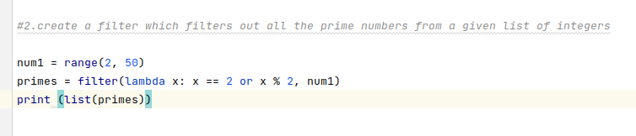

Output:

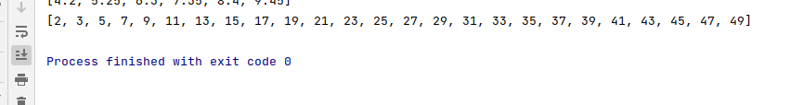

Q3.print the following pattern without using any loops. The input will be length of pattern to be printed: 0, 2, 6, 12, 20, 30, 42, 56, 72, 90.

Soln.

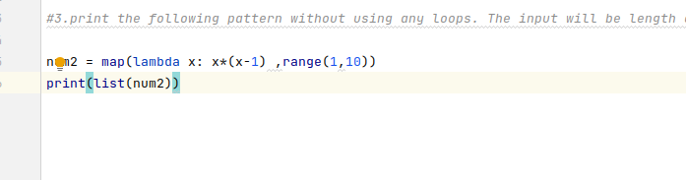

Output:

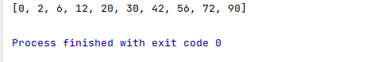

Q4.Debug the above program using pdb, attach screenshots to explain the working of the above program.

Soln.

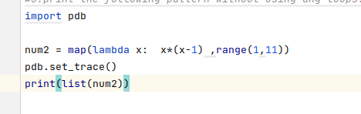

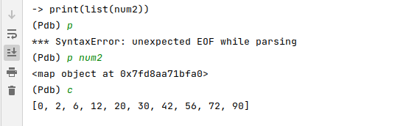

We set debugging point on after num2 .

By writing the command p num2(variable name)

It shows the value assig to num2 and show the object address

After typing c it completes the debugging process and shows the final result

After the break point

Q5.Write a function which takes list of natural numbers as input. Create a dictionary to group the odd and even numbers separately(in a dict). The function should have proper exception handling.

Soln.

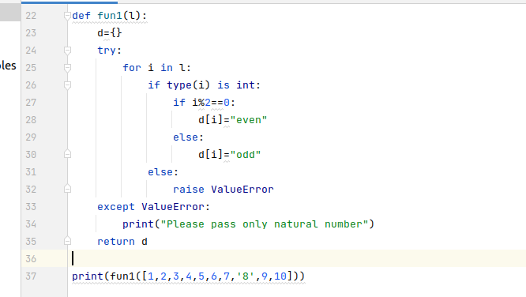



Q6.Create a function "divide" which takes inputs as 2 whole numbers. The function should raise exceptions if denominator is 0, or the passed numbers are not whole numbers.

Soln.

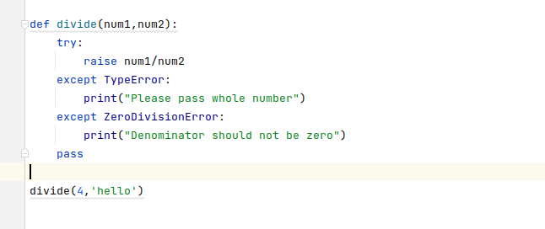

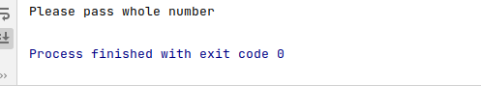

Q7.Write a script that repeatedly asks the user to input an integer, displaying a message to “try again” by catching the ValueError that is raised if the user did not enter an integer.

Once the user enters an integer, the program should display the number back to the user and end without crashing

Soln.

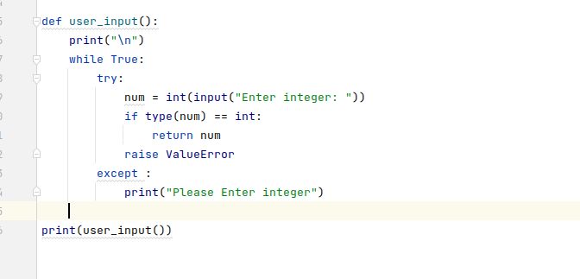

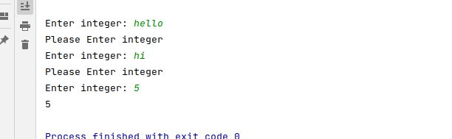

Q8.Write a program that asks the user to input a string and an integer n. Then display the character at index n in the string.

Use error handling to make sure the program doesn’t crash if the user does not enter an integer or the index is out of bounds. The program should display a different message depending on what error occurs.

Soln.

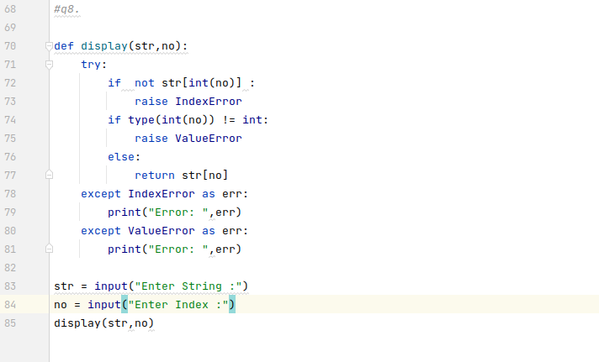

Output

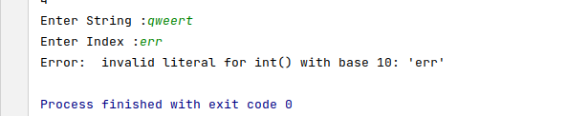

Q9.Write a script that simulates 10,000 rolls of a fair dice and displays

the average number rolled.

Soln.

